**Project Design Phase-II**

**Data Flow Diagram & User Stories**

|  |  |
| --- | --- |
| Date | 11 April 2025 |
| Team ID | SWTID1743607402 |
| Project Name | Shopez: e-commerce application |
| Maximum Marks | 4 Marks |

**Data Flow Diagrams:**

A Data Flow Diagram (DFD) is a traditional visual representation of the information flows within a system. A neat and clear DFD can depict the right amount of the system requirement graphically. It shows how data enters and leaves the system, what changes the information, and where data is stored.

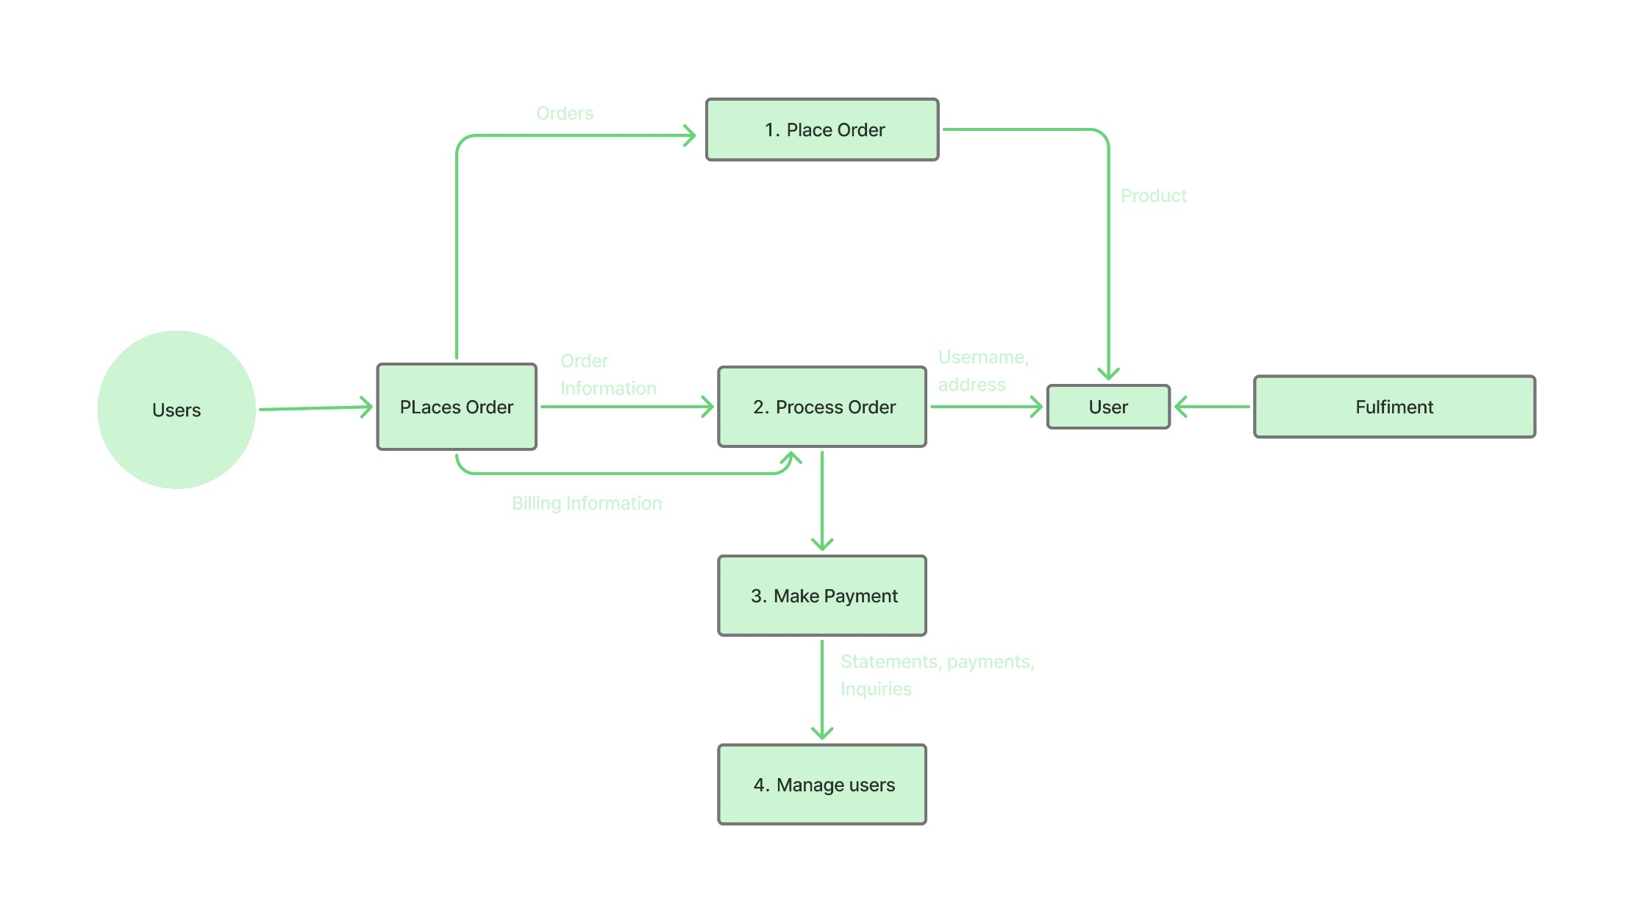

**Figure: User flow diagram for ShopEZ**

**User Stories**

Use the below template to list all the user stories for the product.

| **User Type** | **Functional Requirement (Epic)** | **User Story Number** | **User Story / Task** | **Acceptance Criteria** | **Priority** | **Release** |
| --- | --- | --- | --- | --- | --- | --- |
| **Customer (Mobile)** | Registration | USN-1 | As a user, I can register for the application by entering my email, password, and confirming my password. | I can access my account/dashboard after registration. | High | Sprint-1 |
|  |  | USN-2 | As a user, I will receive a confirmation email once I have registered. | I receive and click a confirmation email to verify my account. | High | Sprint-1 |
|  |  | USN-3 | As a user, I can register using Facebook login. | I can log in and access the dashboard via Facebook. | Low | Sprint-2 |
|  |  | USN-4 | As a user, I can register using Gmail. | I can log in and access the dashboard via Gmail. | Medium | Sprint-1 |
|  | Login | USN-5 | As a user, I can log in using email and password. | Successful login redirects me to my dashboard. | High | Sprint-1 |
|  | Dashboard | USN-6 | As a user, I can view available products on the dashboard. | Product list is displayed with name, price, and image. | High | Sprint-2 |
|  | Product Management | USN-7 | As a user, I can add products to my cart. | Product is added to cart and visible in cart page. | High | Sprint-2 |
|  |  | USN-8 | As a user, I can place an order from my cart. | Order is confirmed and order ID is generated. | High | Sprint-3 |
|  | Order History | USN-9 | As a user, I can view my past orders. | List of past orders with order status and amount. | Medium | Sprint-3 |
| **Customer (Web)** | All mobile features + web UI | USN-10 | As a user, I can access the same features on a web interface. | Registration, Login, Cart, and Orders work on web. | High | Sprint-3 |
| **Customer Care Exec** | View Customer Orders | USN-11 | As a CCE, I can view customer order history and status. | Able to search and view orders by user ID/email. | Medium | Sprint-4 |
|  | Support Management | USN-12 | As a CCE, I can create and respond to customer support tickets. | Tickets are logged and visible in dashboard. | Medium | Sprint-4 |
| **Administrator** | Product Management | USN-13 | As an admin, I can add, edit, and delete products. | Changes reflect in the product catalog immediately. | High | Sprint-2 |
|  | User Management | USN-14 | As an admin, I can view and manage registered users. | Admin can search, ban or delete users. | High | Sprint-3 |
|  | Order Management | USN-15 | As an admin, I can view and manage all orders. | Admin can update status and view detailed info. | High | Sprint-3 |
|  | Dashboard Analytics | USN-16 | As an admin, I can view analytics like daily orders and revenue. | Graphs and stats are visible on the admin dashboard. | Medium | Sprint-4 |